F.3 Physics Worksheet 1
Experiment : Calibrating an unmarked liquid-in-glass thermometer

Aim : To use an unmarked liquid-in-glass thermometer to measure an unknown temperature.

Apparatus : unmarked liquid-in-glass thermometer, half metre-rule, beaker, ice, water, heater.

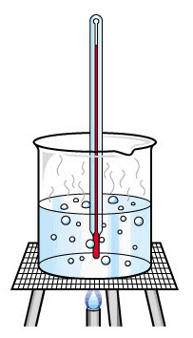
Procedure :
boiling water
100 °C
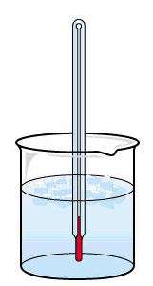
unmarked
thermometers
melting ice
0 °C

1. Put the unmarked thermometer in melting ice.
2. Measure the height of level of the liquid column from the bottom of thermometer at 0 ºC as L₀
3. Put the thermometer in boiling water.
4. Mark the height of level of the liquid column from the bottom of thermometer at 100 ^{O}C as L₁₀₀
5. Measure your body temperature using the unmarked thermometer by recording the length of the liquid column at the temperature to be measure as L_{T}.
- Calculate the temperature by graphical method or by calculation.

Results :
 | Temperature / ºC | Height of liquid column / cm
Lower fixed point
Upper fixed point
Your body temperature | ?

Calculation :

